[06-03-2020 11:56 IST ]Changes Log:

1. Corrected the Admin class.

2. Corrected the Token function.

3. Removed the new user and registered user and made a single " User" which is equivalent to New User as implementing Registered user would require data file handling which would unnecessarily complicate things at this final stage.

Finally there is prompt:

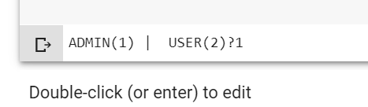

Admin gives append options along with all the features of user class.

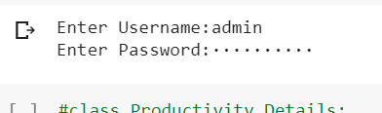

------------------------------------------------------------------------



------------------------------------------------------------------

4. Tweaked YES Yes Y y for more smooth experience. All other strings are considered as NO.